# Logo Development

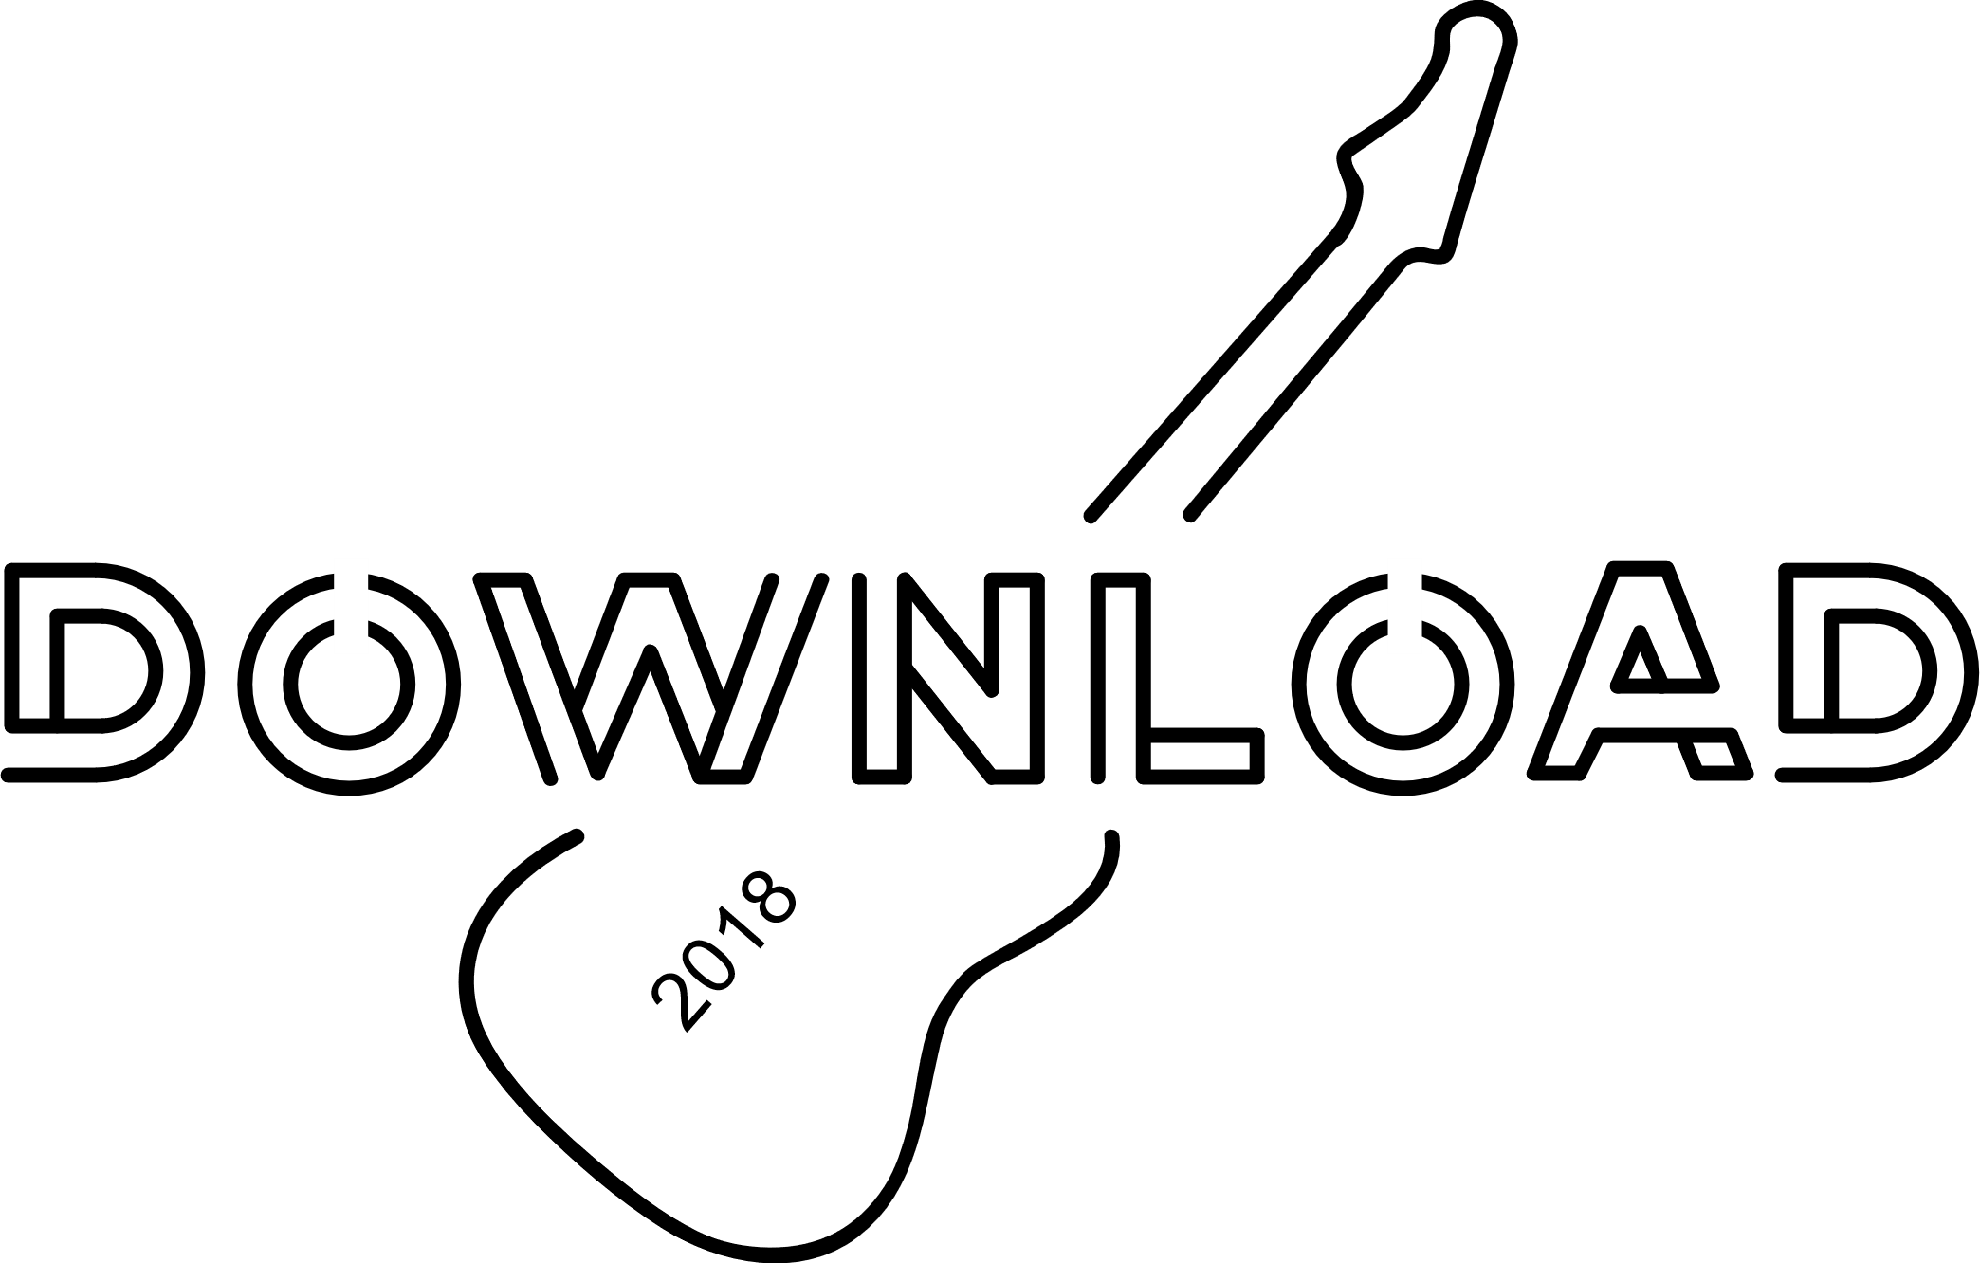

I Chose this Logo to develop as I think it was the best out of the Designs I created. although I don’t think the font suits the target audience in its current state, I think that the other main element of the logo, the guitar in the background, is something I want to take forward in my designs. However, I will implement parts of my other designs, more notably the bubble around the second illustrator design and the font from the second one as well.

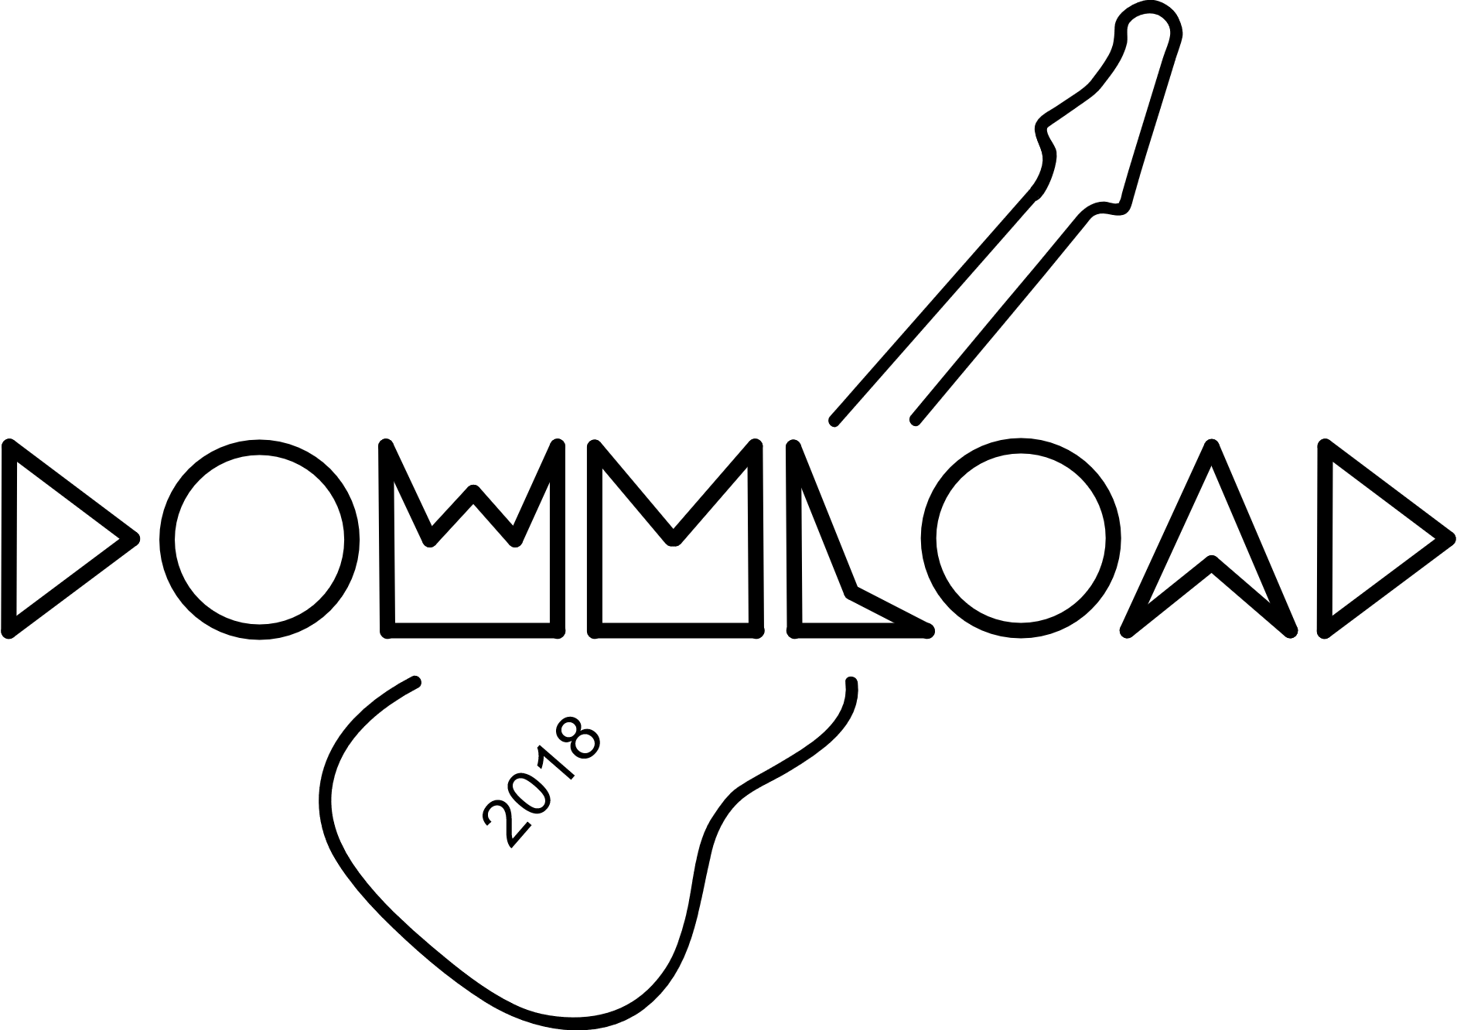

In this development, changed the font of the logo. This font suits the target audience better, however in this development of the logo the font doesn’t fit in with the guitar, however I will keep the font for now as it will work better when the logo is developed more.

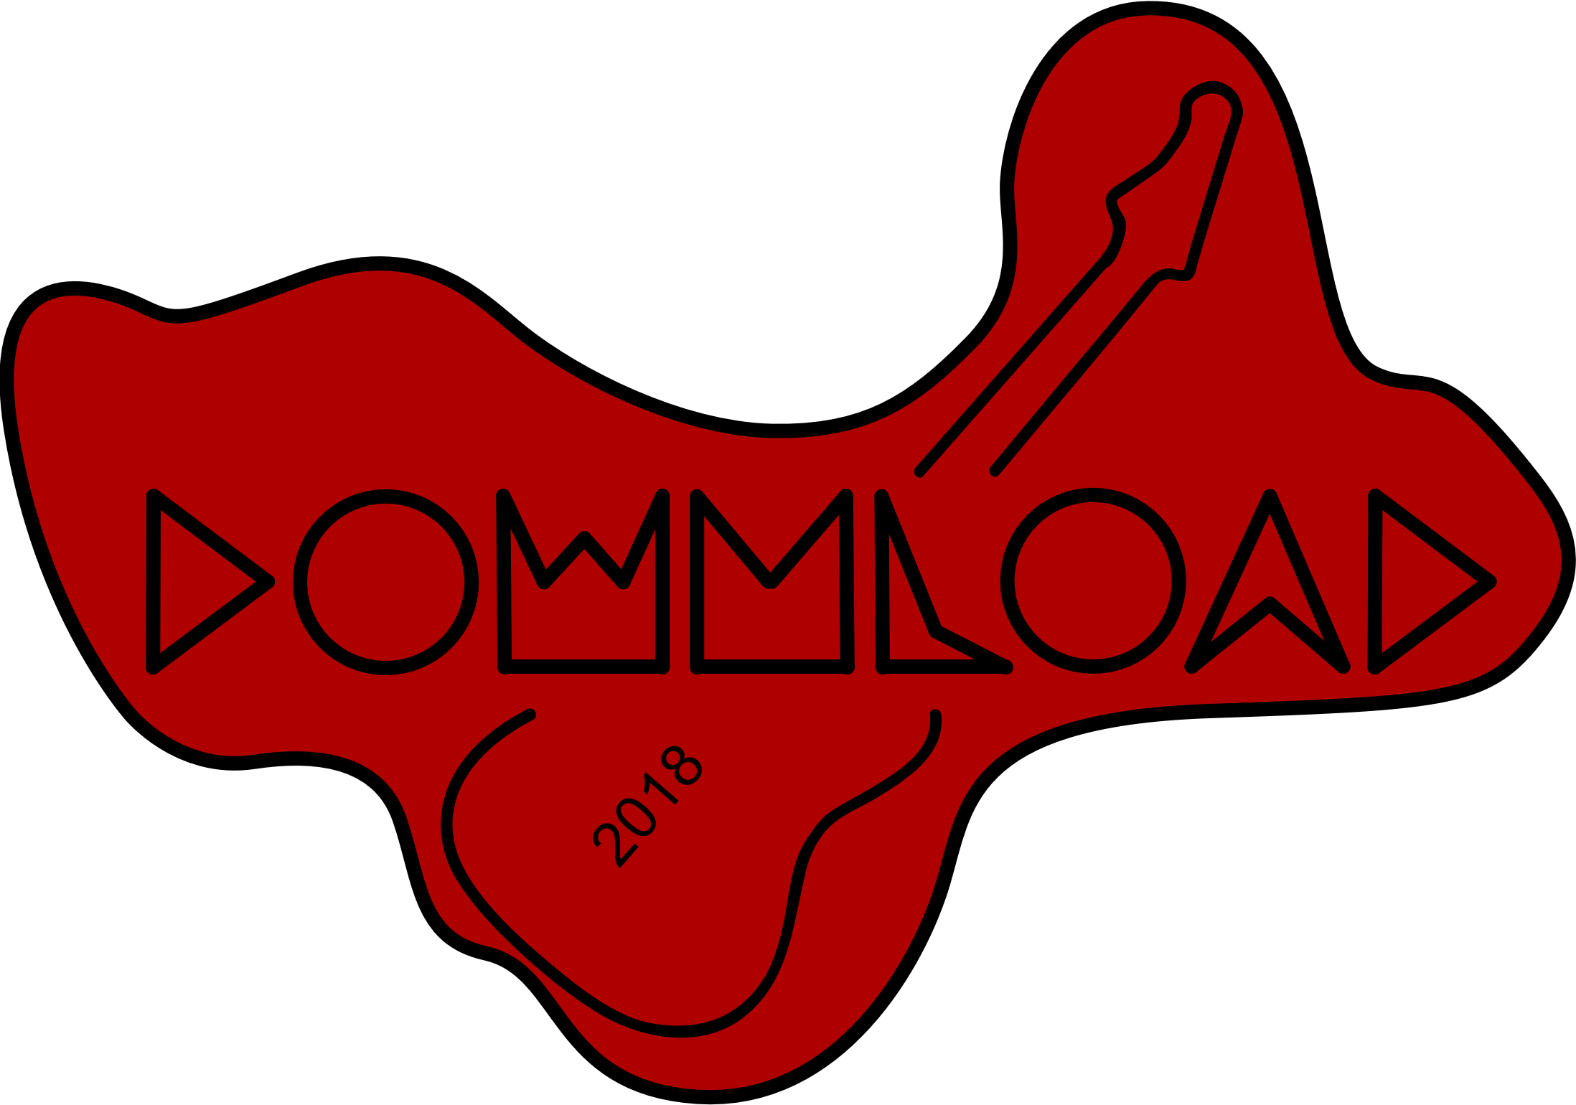

This development of my logo is probably the worst iteration. The Red suits the target audience well, however its quite dull and doesn’t draw attention to itself. This makes the logo overall quite boring. The shape around the text has no meaning to the festival and is therefore useless and the logo would probably look better without it in this case.

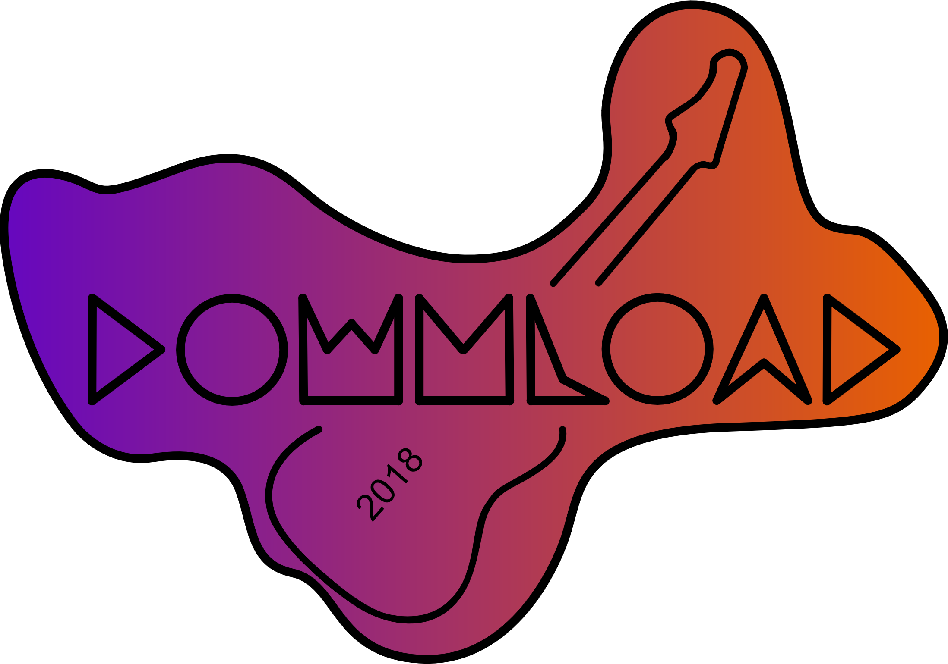

This version improves on the last one slightly, as the gradient is brighter and more eye catching. However, the shape around the text remains and is still useless to the design.

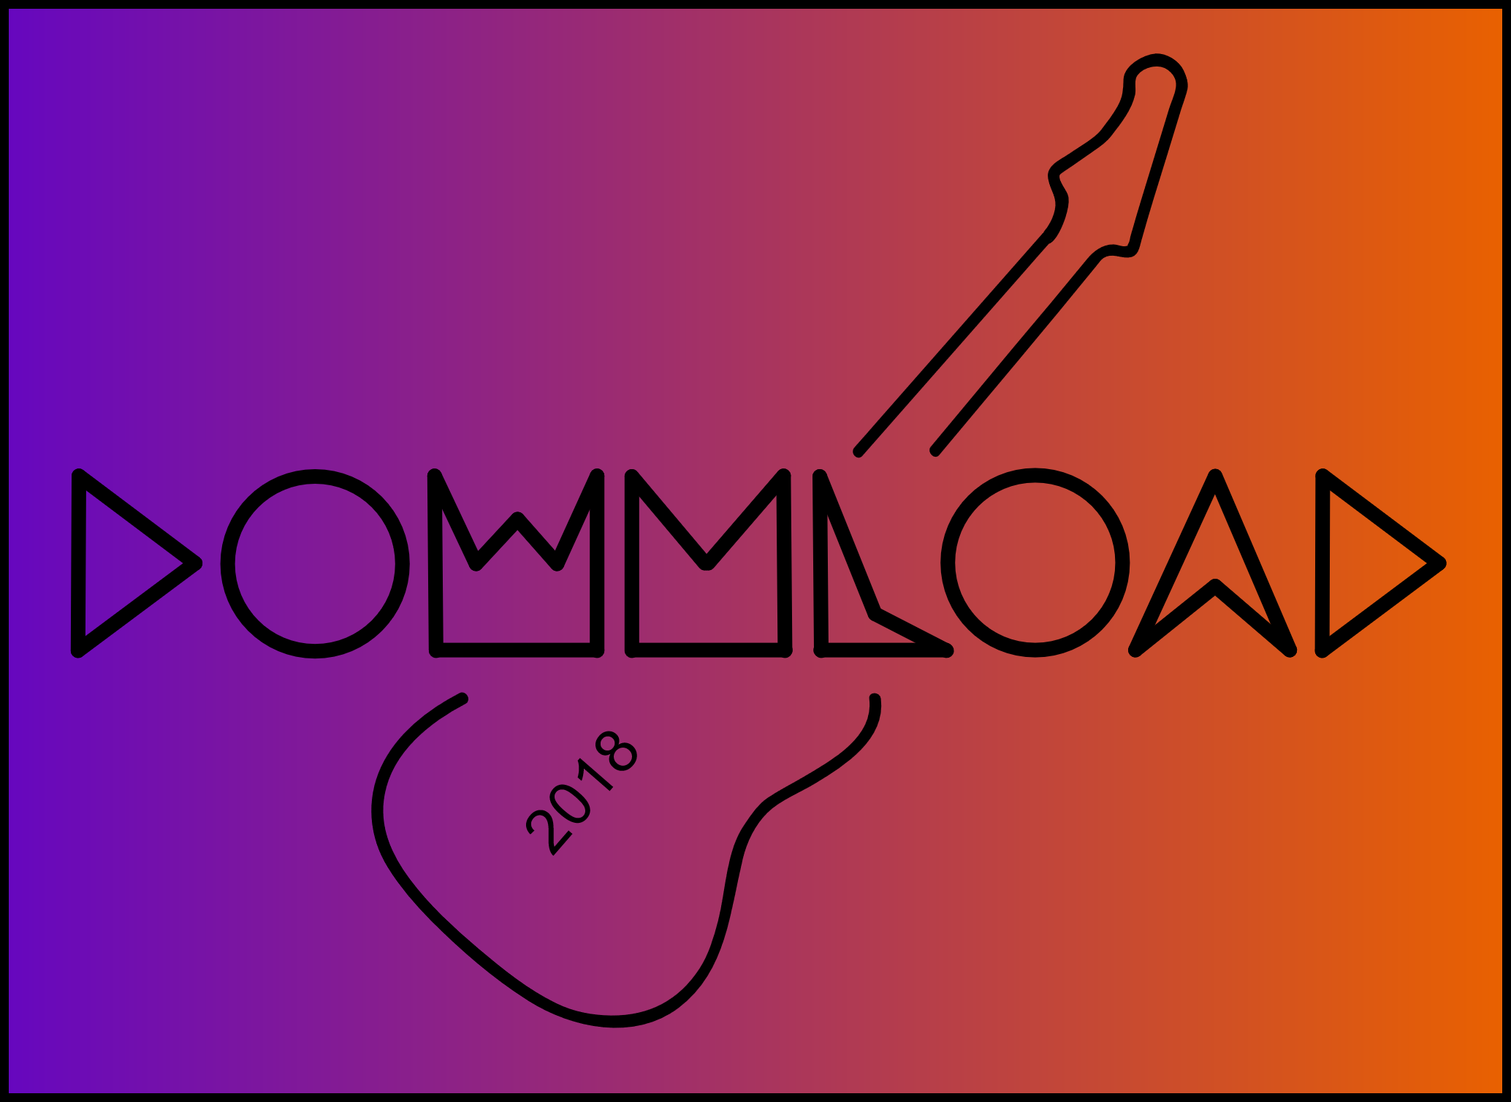

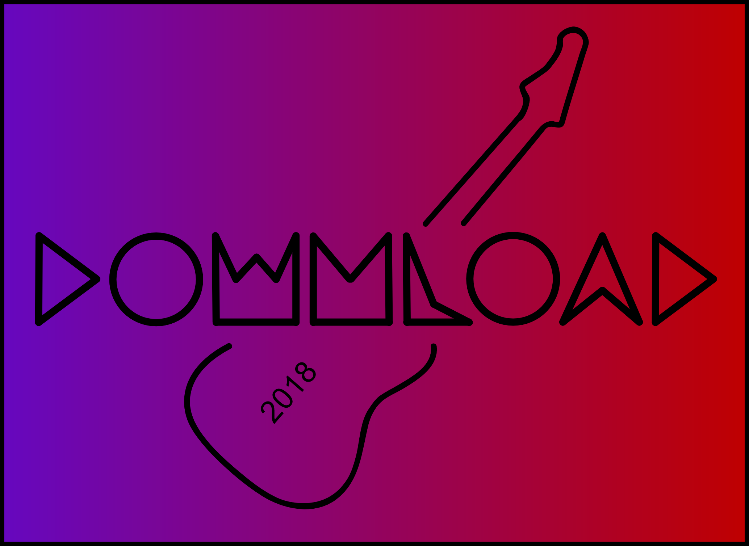

In these developments I removed the bubbly shape from around the test and replaced it with a rectangle. This looks more clean, however it’s a lot more boring and no-where near as eye catching. I think that this development is probably the worst and most boring.

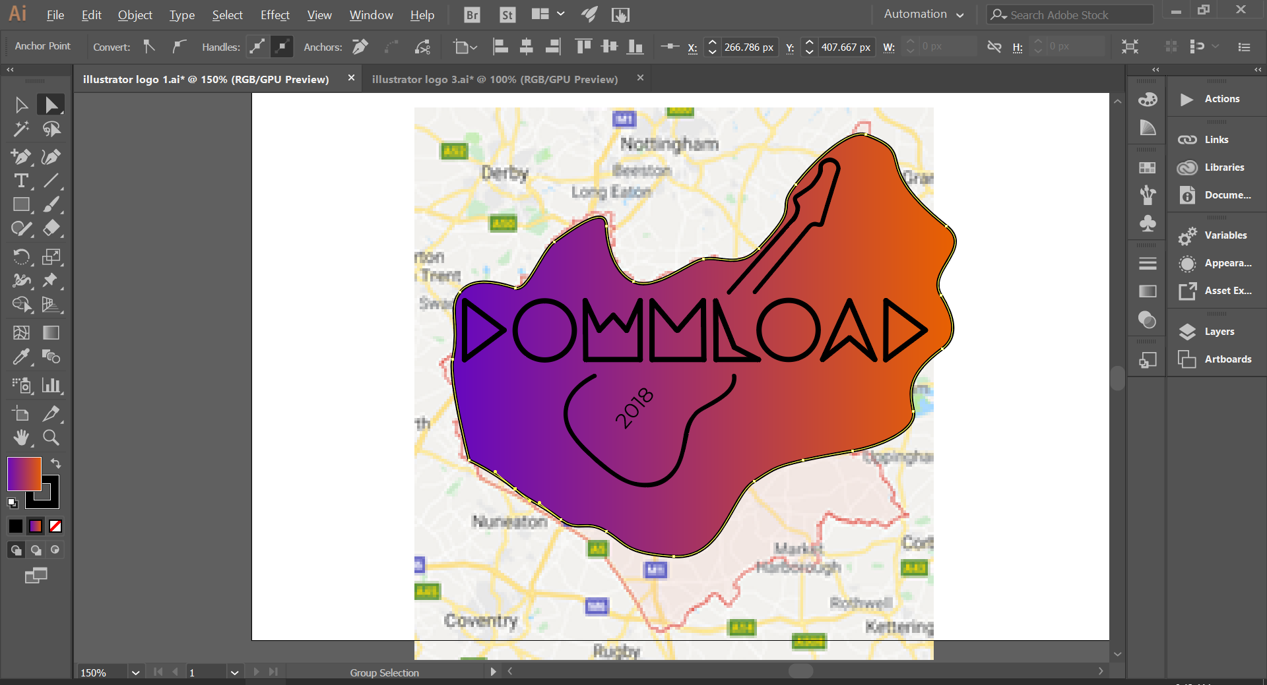

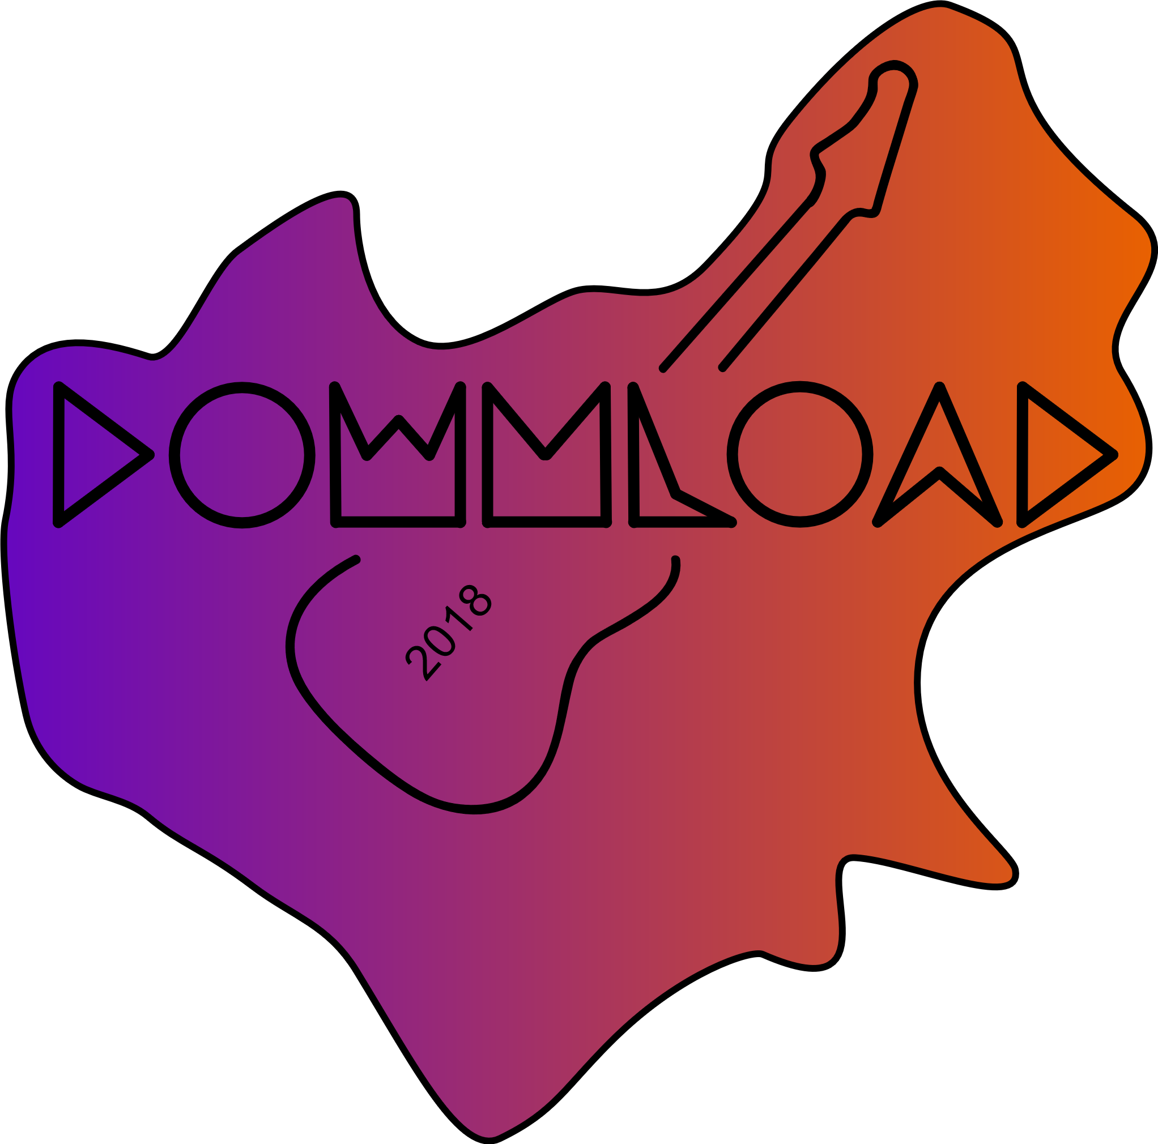

In this iteration, the shape has been given purpose. it now is in the shape of Lincolnshire, in which the festival is based. Alternatively, I could have made it in the shape of the Donnington track, which is the location of the festival in Lincolnshire, however that shape wouldn’t have been big enough to fit the guitar and the name at the same time and wouldn’t have worked well. Although nearly everyone won’t notice that its Lincolnshire, the shape provides a background so its easier to read the text, and the bright colours of the shape draw the attention of people. To make it the shape on Lincolnshire, I imported a google images screenshot of Lincolnshire, and adjusted the points so that it’s the same shape as Lincolnshire.

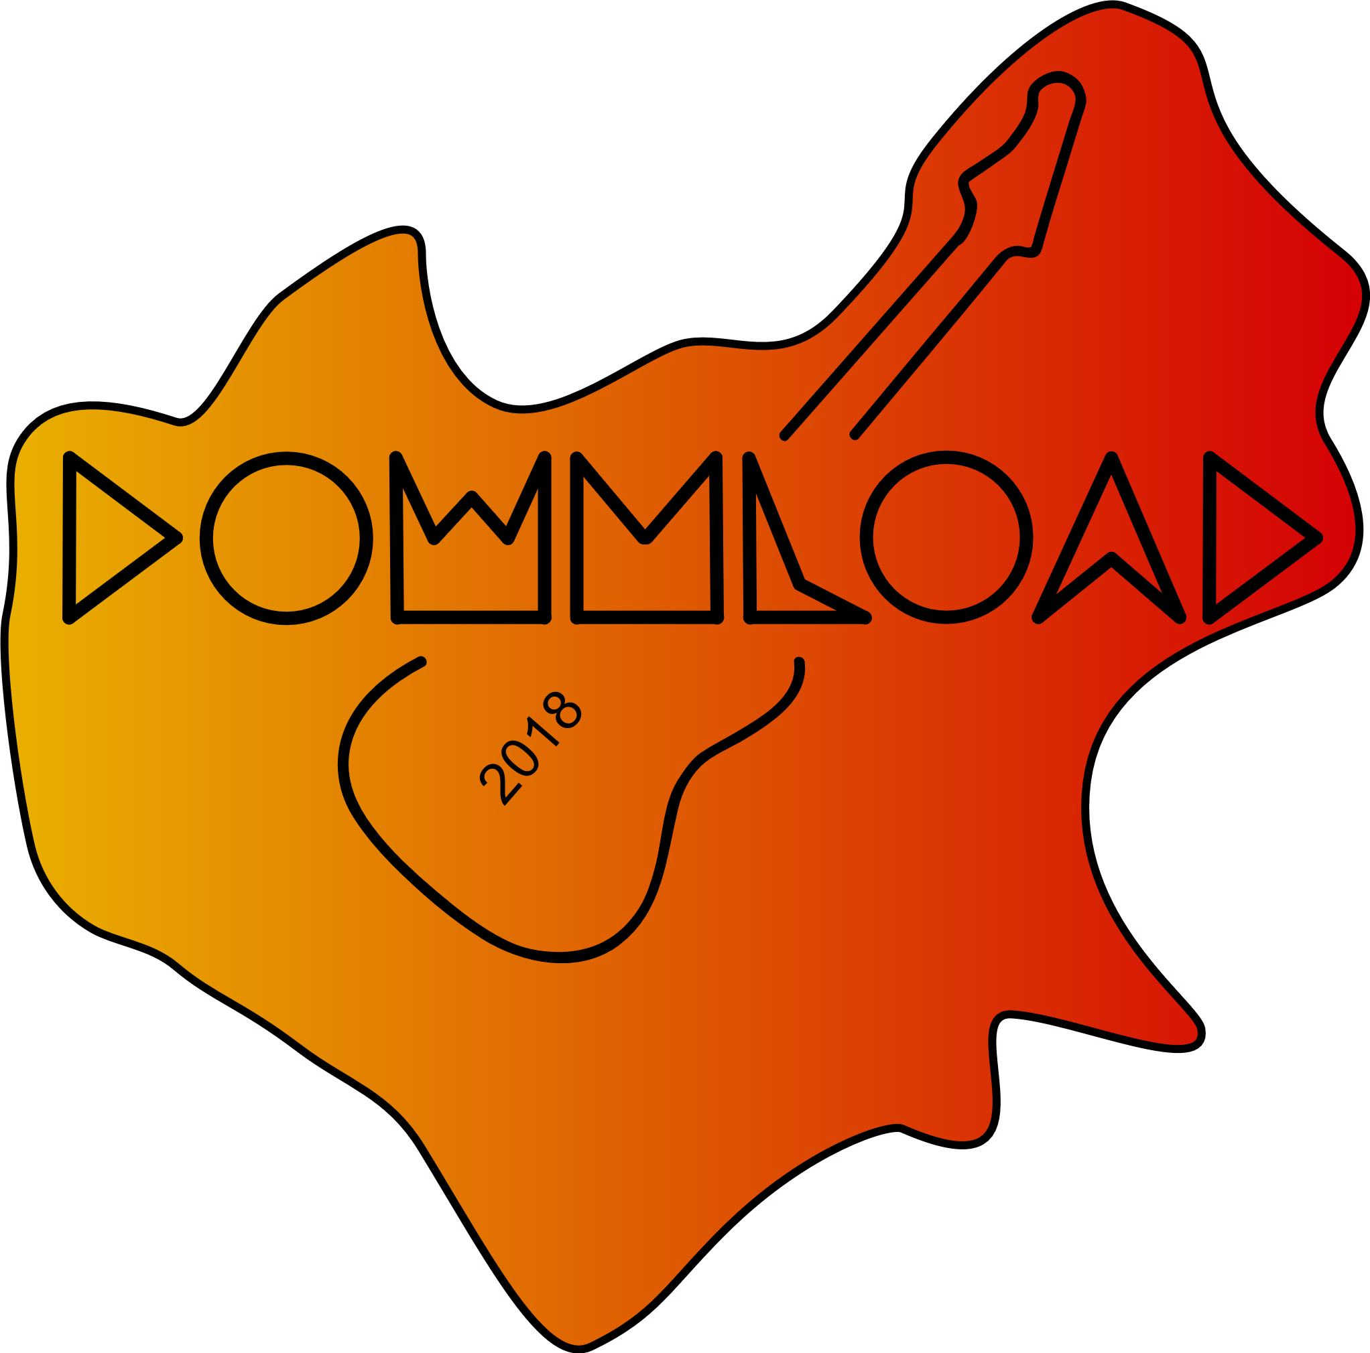

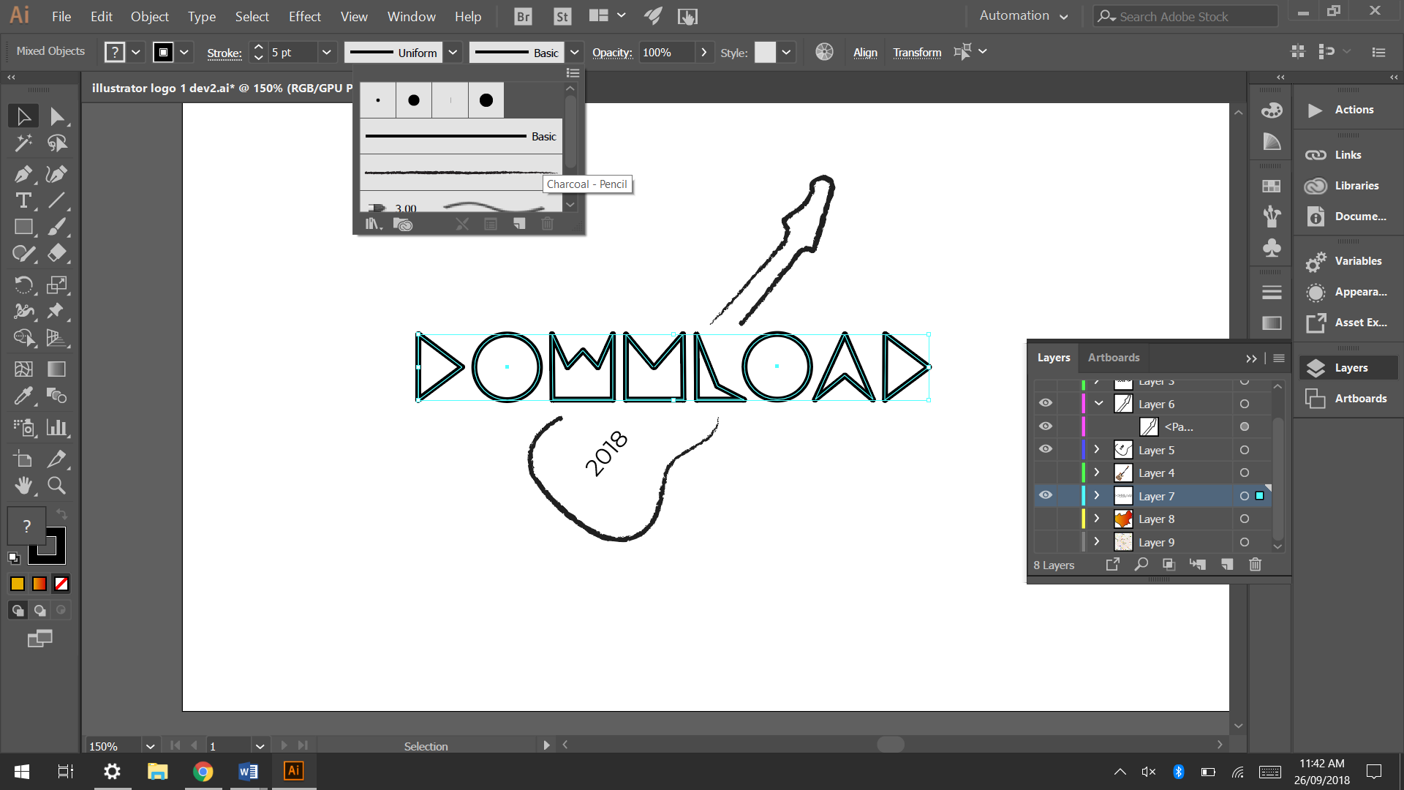

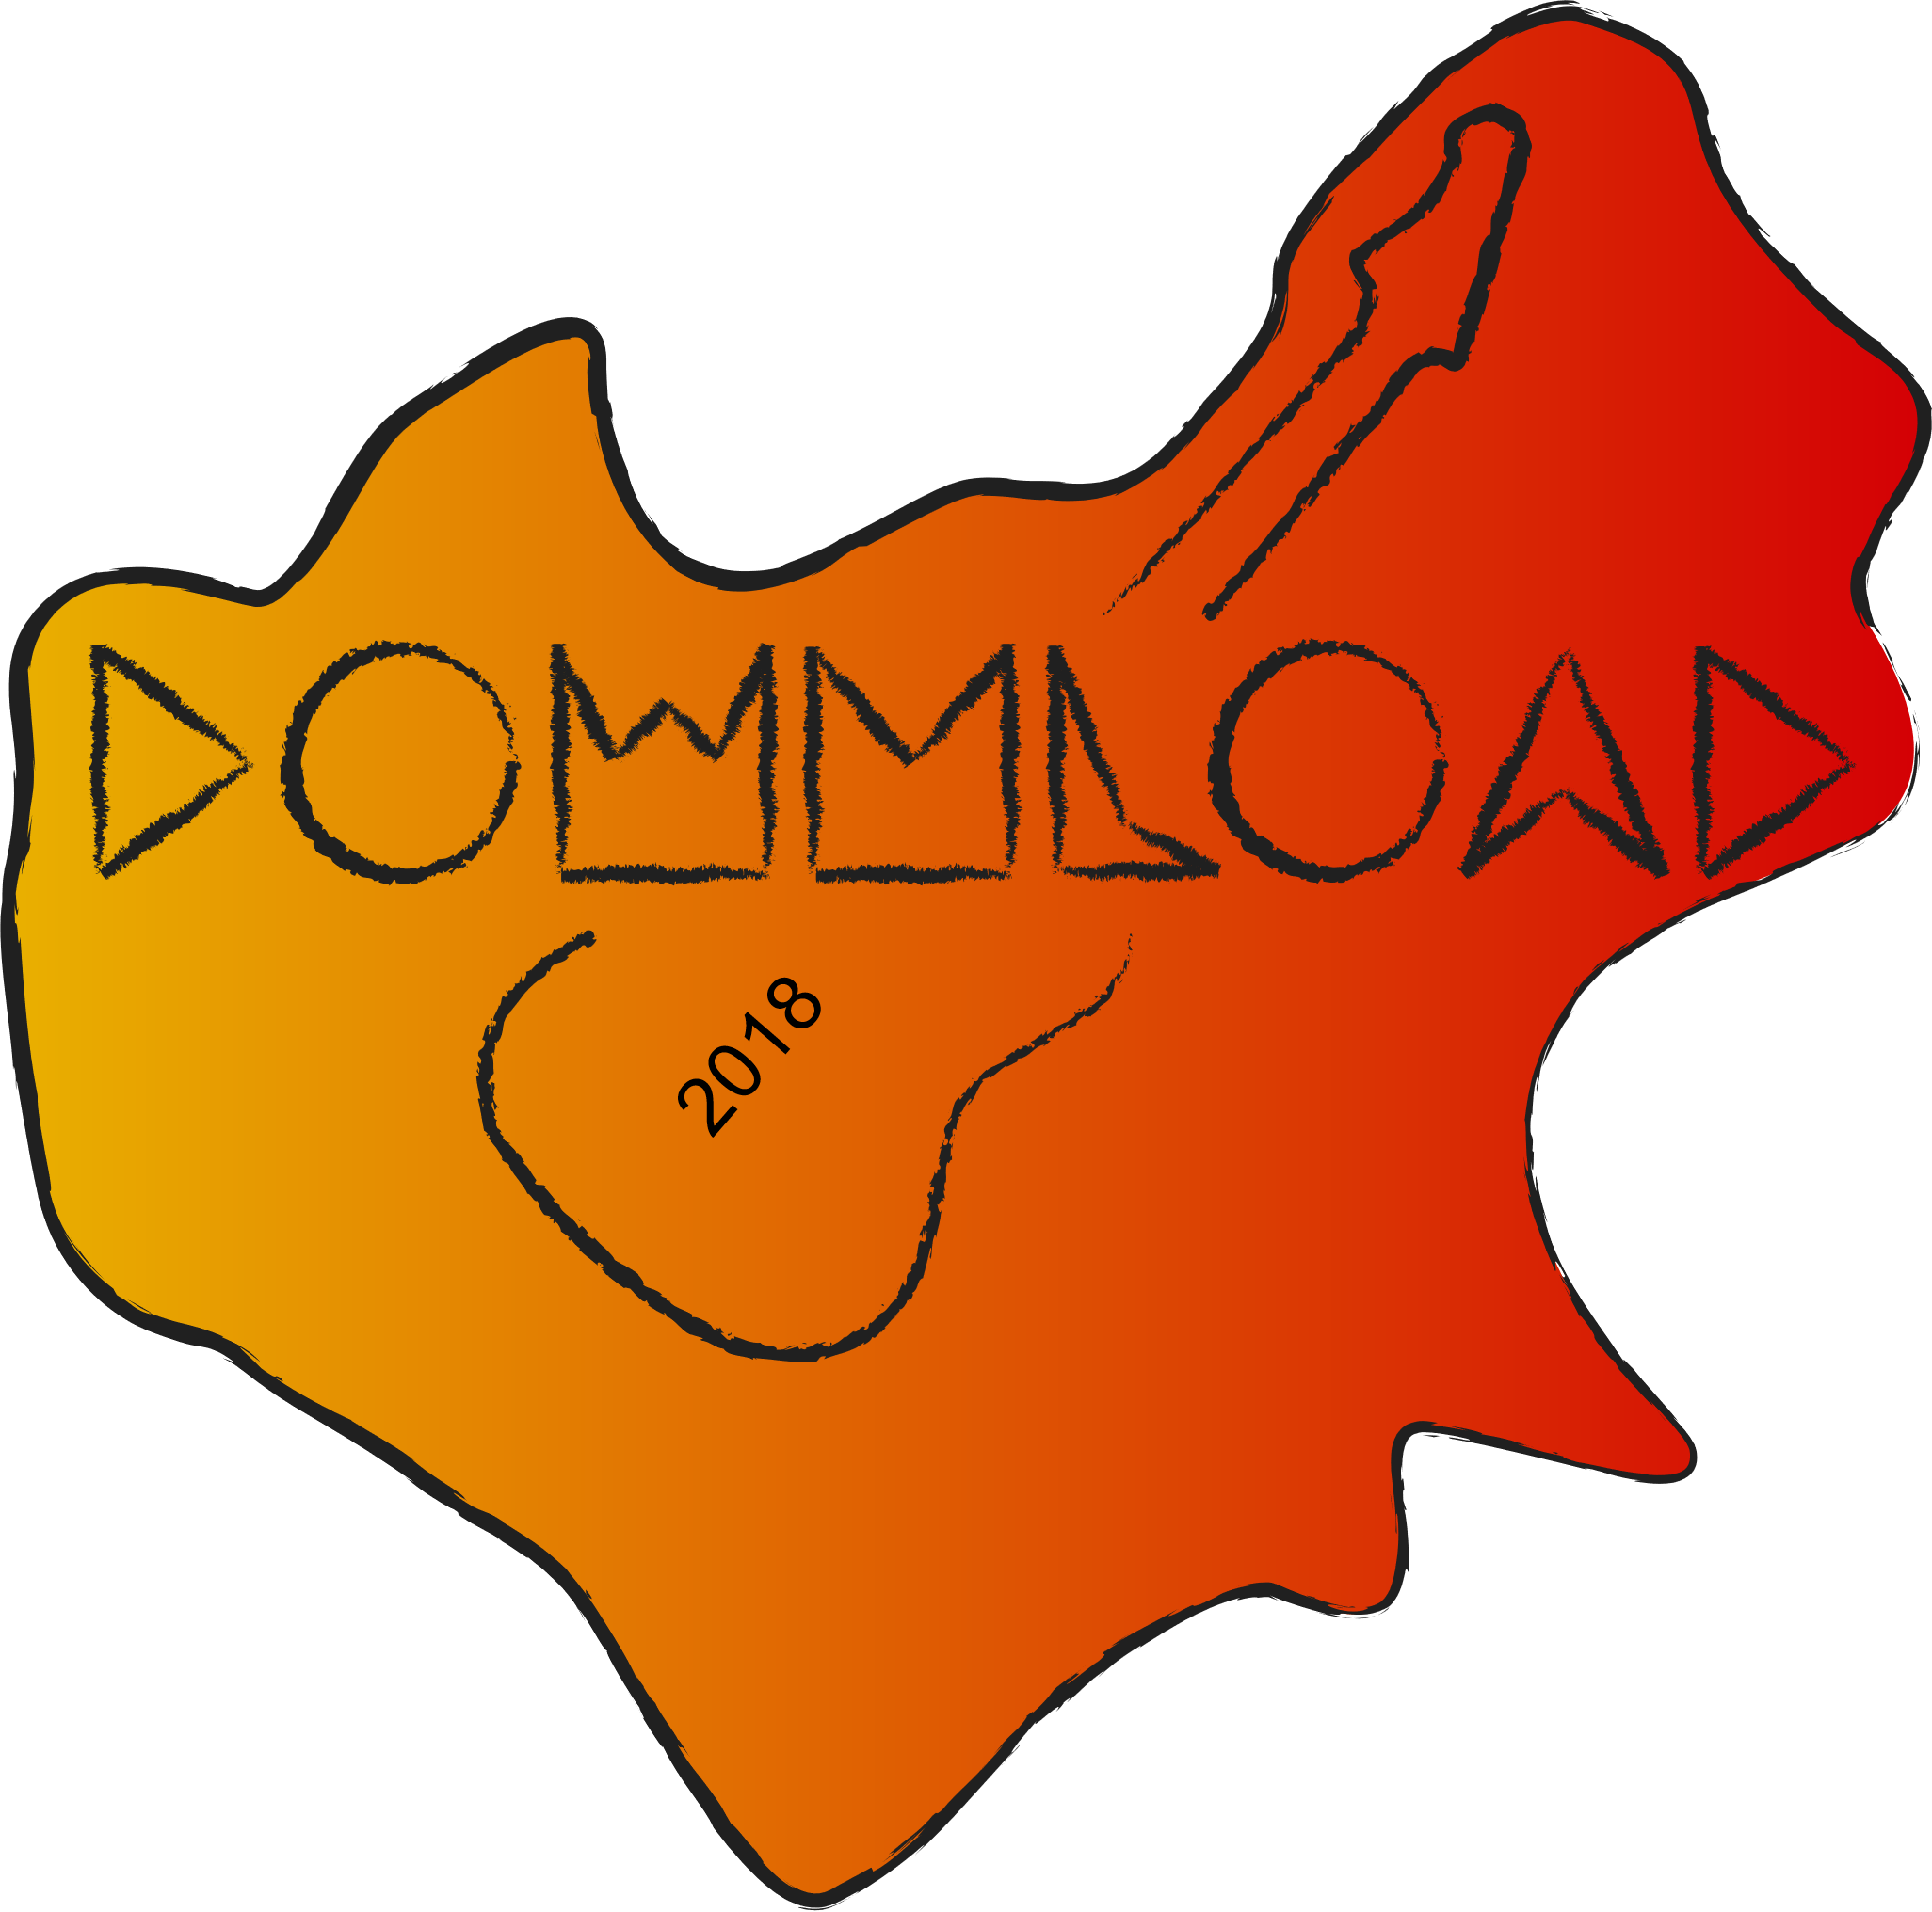

In this development I added texture and detail to all the lines on the logo. I think this made the logo target the target audience more and made the logo look more interesting.

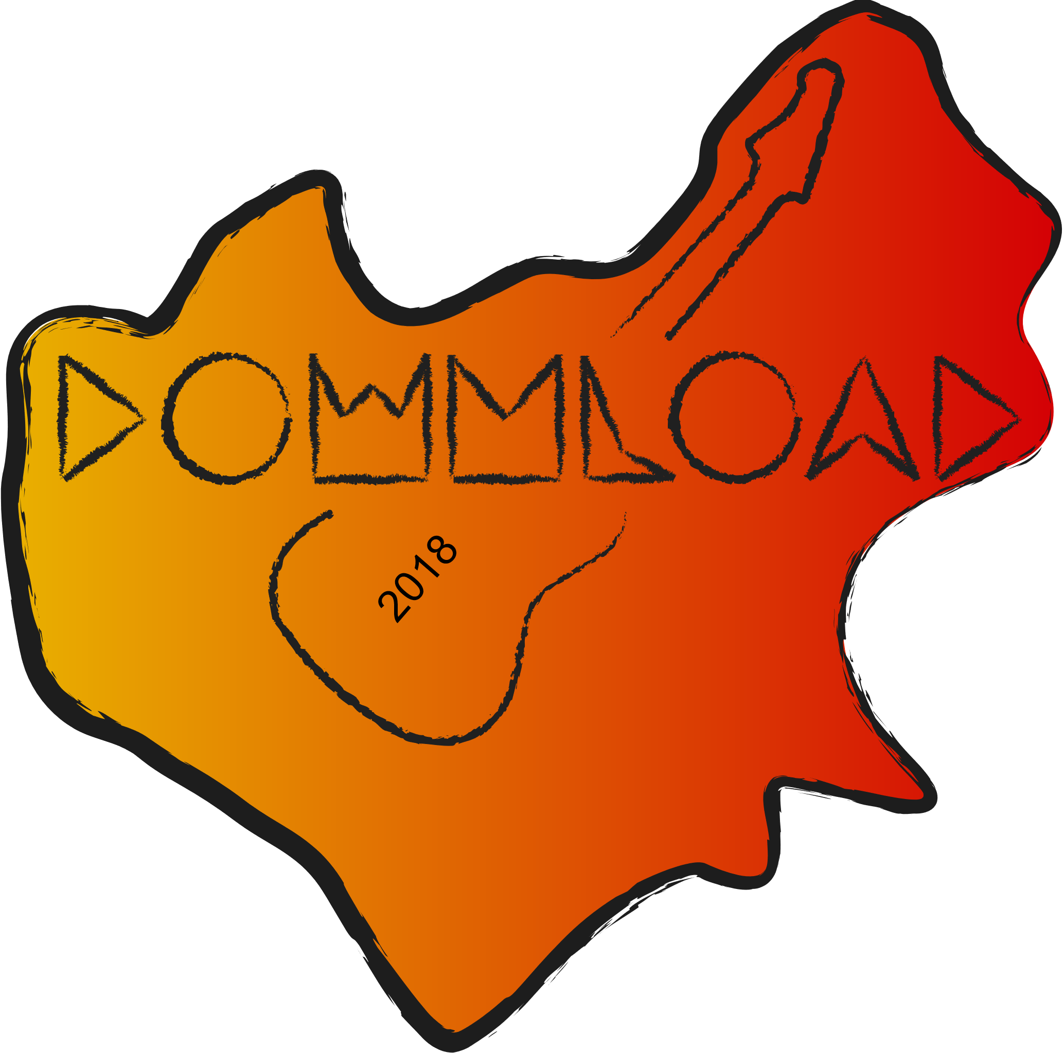

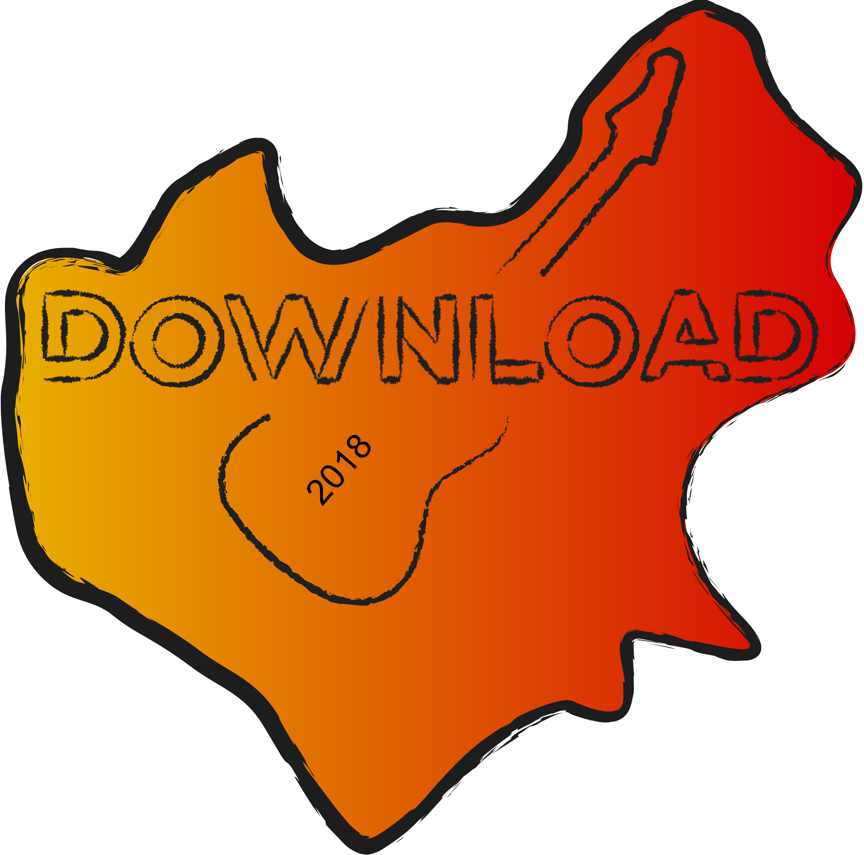

I ended up replacing the font with the original font which was replaced at the start of the development. I did this because the previous font was quite hard to read, and the letters N and M were commonly misread, as they looked like ‘W’s.

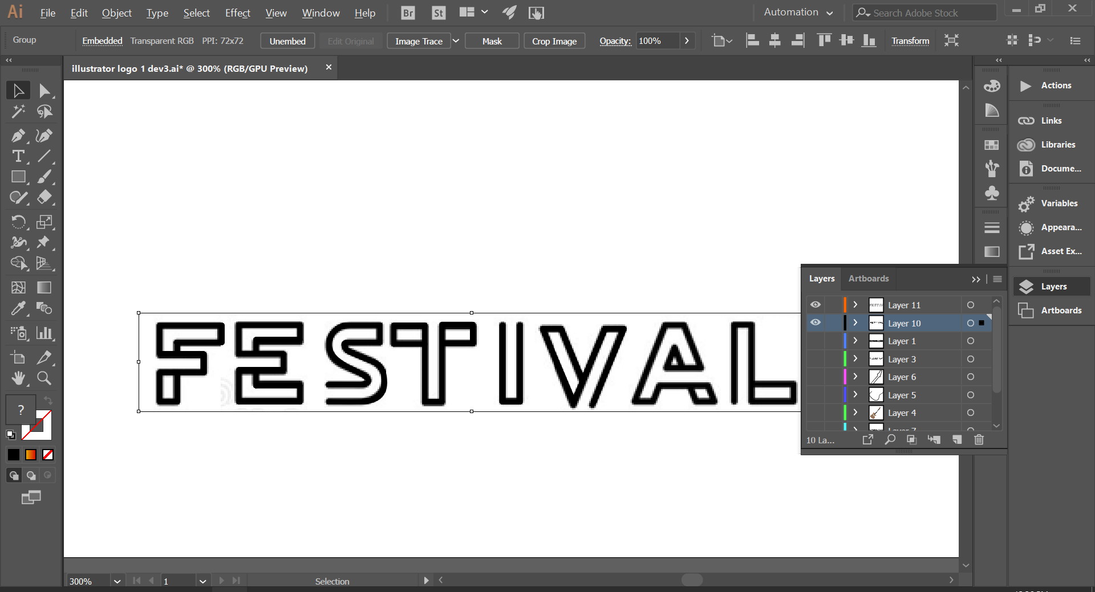

­­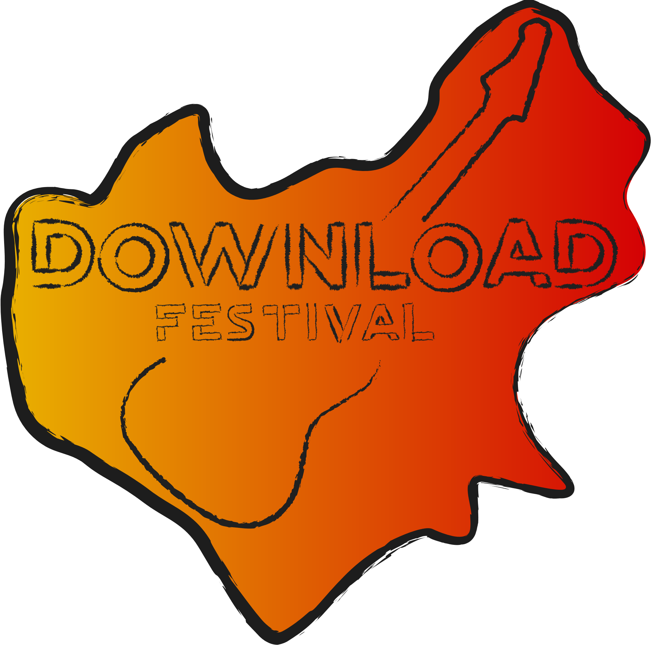

I added the word festival to the logo so that its more clear what the logo is for. To do this I used the same lettering as on the word download, and extended the guitars neck so it has enough room for the word fetival as before it did not.

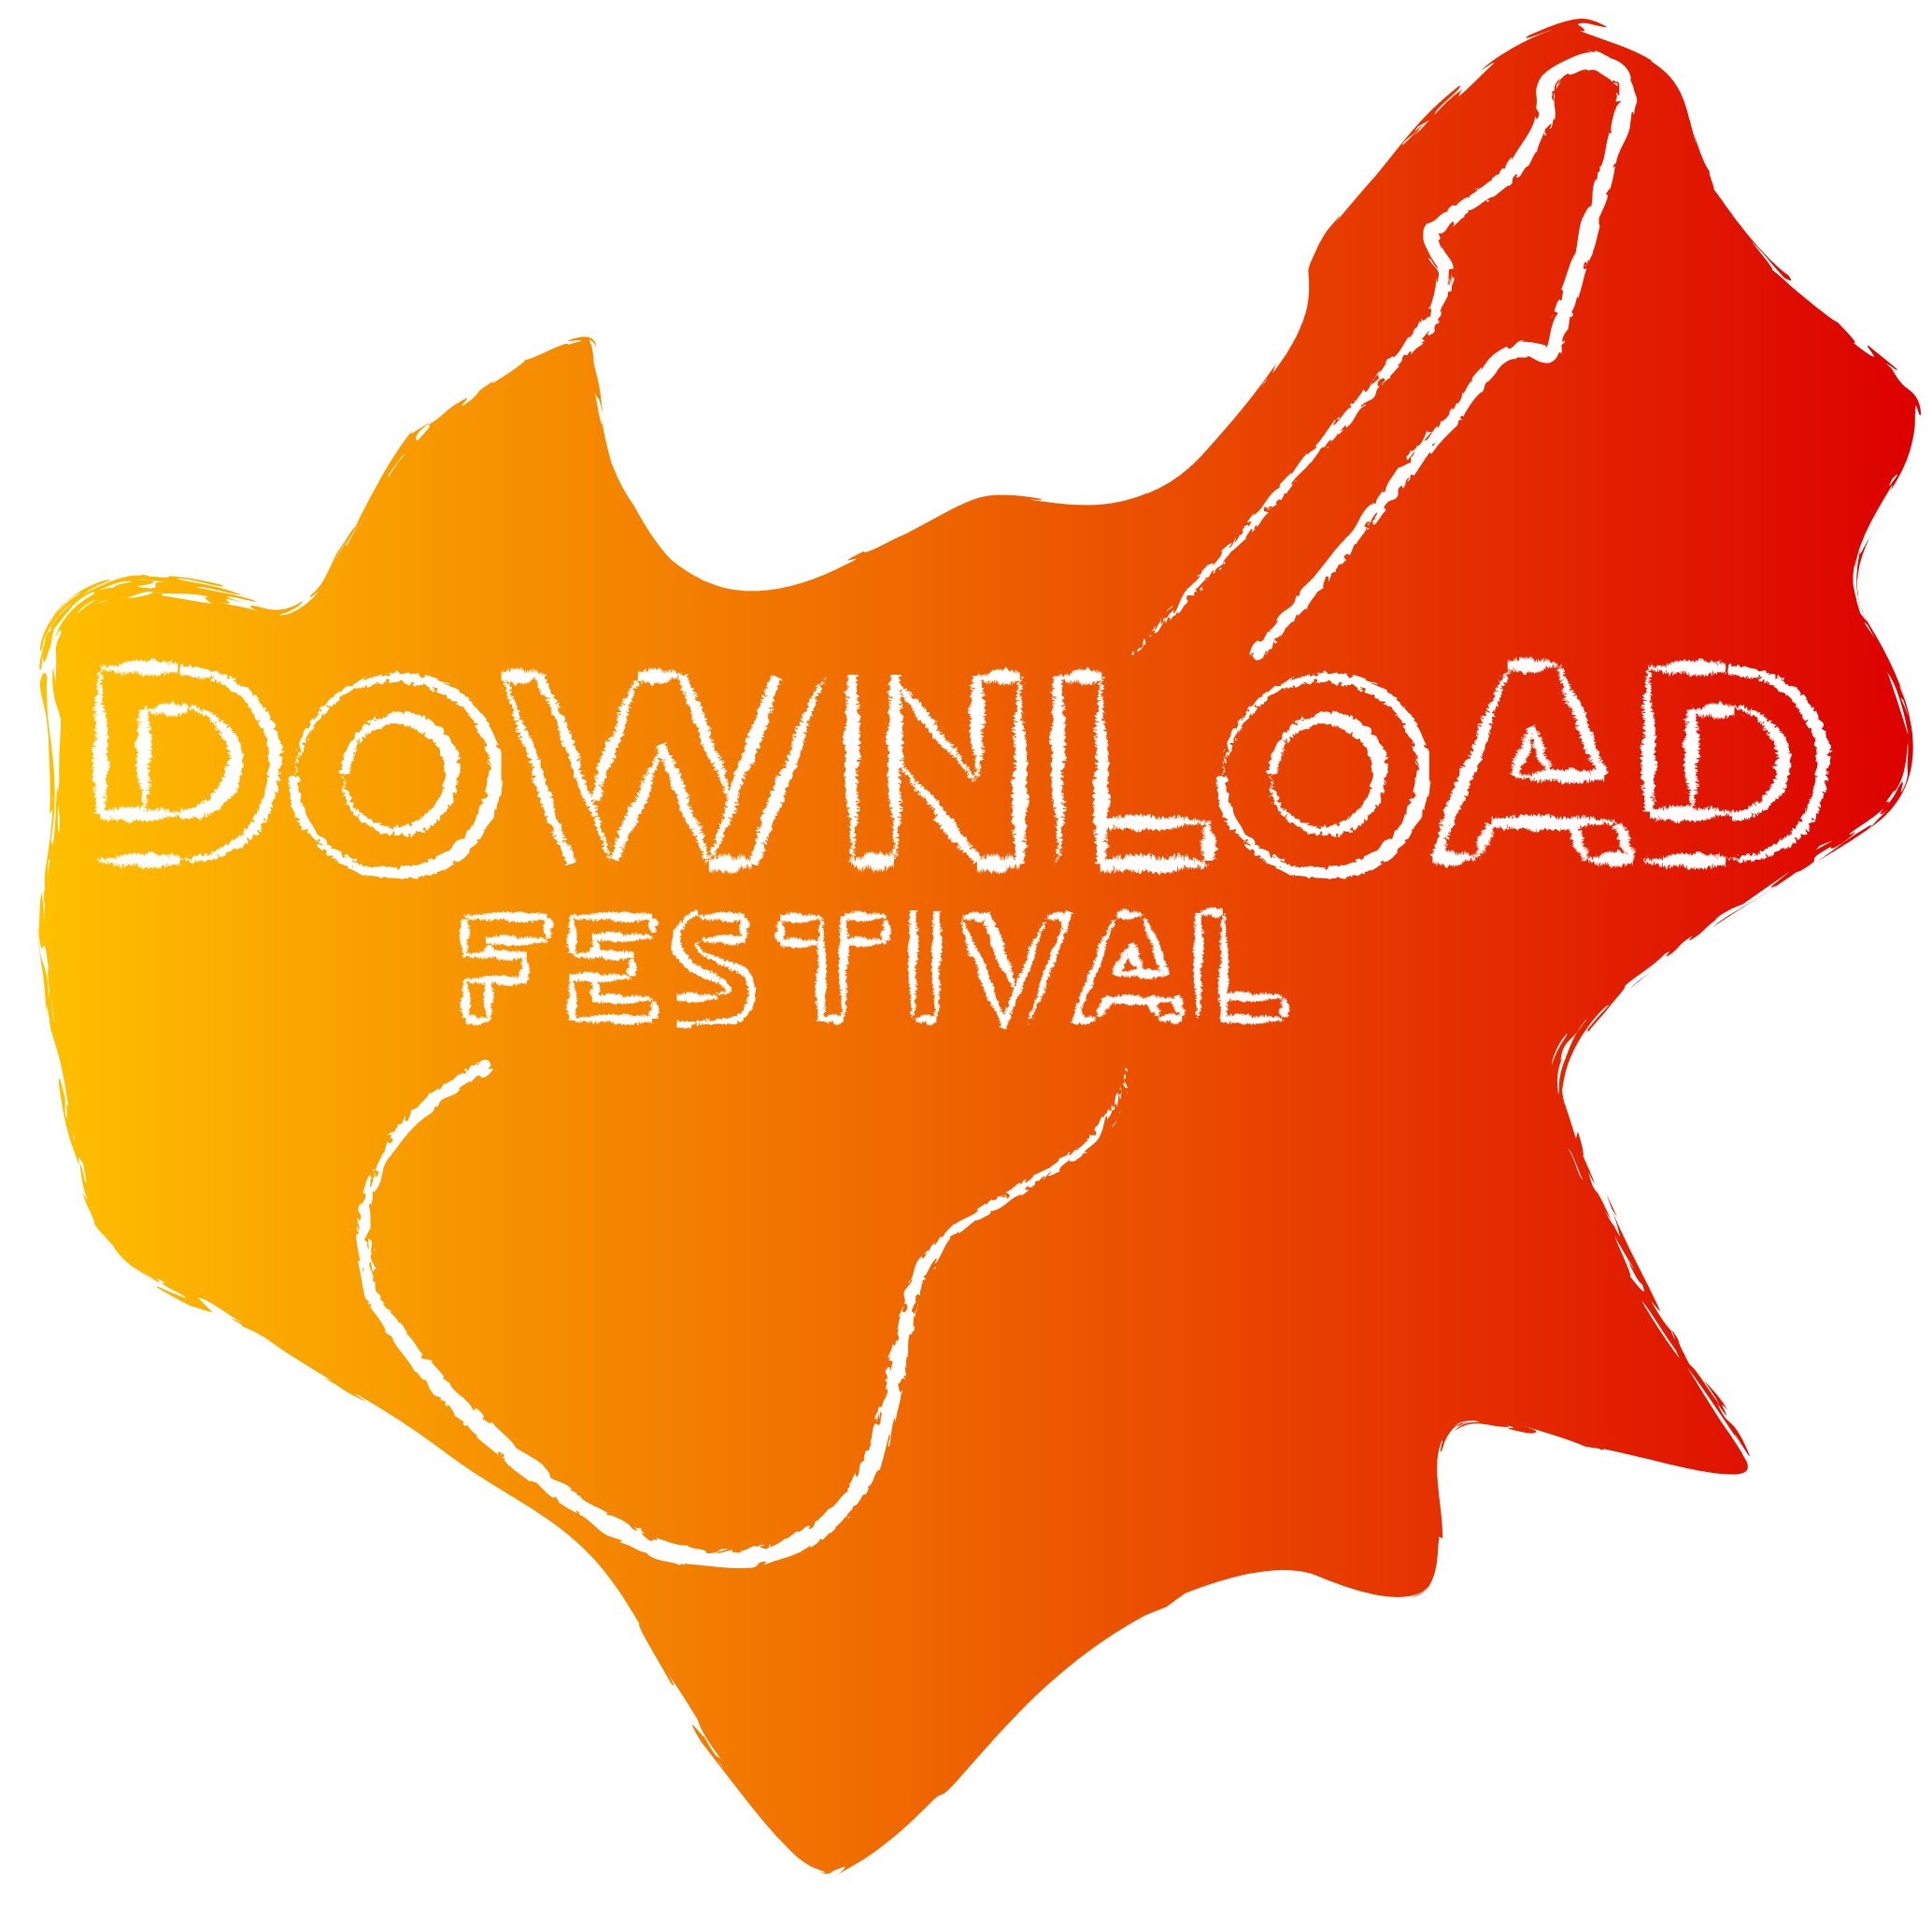

I have two versions of the final development, a darker version and a lighter version. Although I personally prefer the lighter version, I don’t think it suits the target audience as well as the darker version. I also think that creating icons and banner images that align with the lighter theme would be more challenging and unnecessary, especially considering the darker version would work better for the festival. The final development continues the theme of the guitar through the middle, however, other elements have been changed. For example, the original logo with the guitar didn’t contain a bubble around it, or the word festival. The word festival was added for clarity reasons, as in the original design it was unclear what the logo was for. The bubble around the logo was added so that its easier to read the test. The bubble appears to be in an unusual shape, but its actually in the shape of Leicestershire which is where the festival is hosted. This most likely won’t be noticed by most people, however I thought it would be best to link it in some way to the festival rather than having a random shape around the edge. I removed the year that was seen in previous developments so that the logo can be used year after year without needing to be changed. I also went back to the original font as its much easier to read than the one that was previously used. For example, the letters ‘N’ and ‘M’ were unclear to read, and some people mistook the ‘M’ for a ‘W’. the colours for the gradient were changed from Red and blue to red and yellow. I changed it to a fierier colour scheme because it suits the target audience better and links the logo to the festival.